Project Database Design

## Stored Procedures:

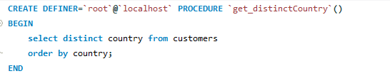

Procedure with input parameters:

1. Stored procedure allows you to give the input parameters with three keywords IN,OUT,INOUT
2. IN keyword - input value to be supplied
3. OUT keyword - output to be returned

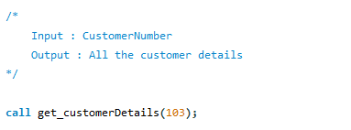

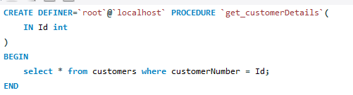

**Task:**



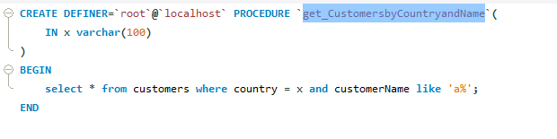

**Task:**

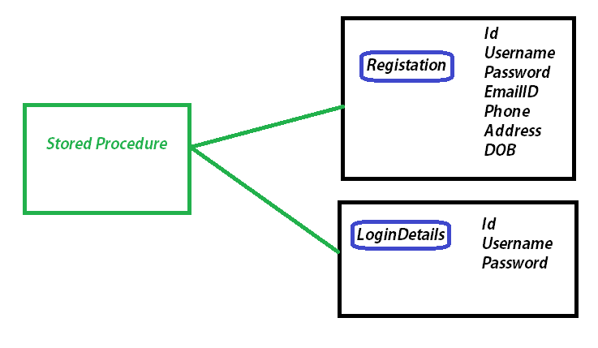

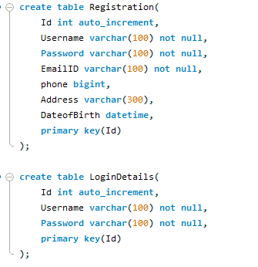

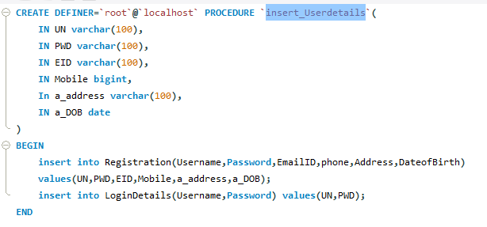

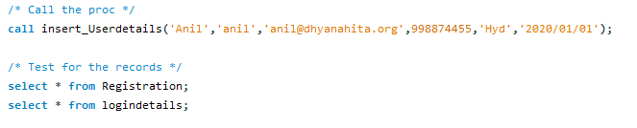

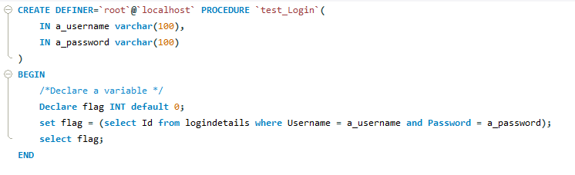

It means the username and password is correct so that it returns the ID value.

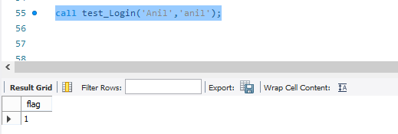

It means that the username and password is incorrect.

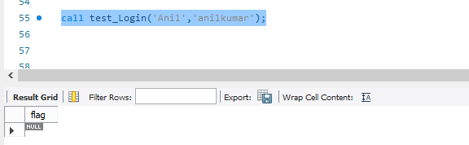

**Task: Update the Password (registration and logindetails) then it notify that record is updated.**